If you are **NOT using Kubernetes** and want to **view server logs in a clean, powerful UI**, here are the **best practical options** (from simple → enterprise-grade). I’ll clearly tell you **what to choose and why** 👇

**🟢 Best Overall (Most Popular): ELK Stack**

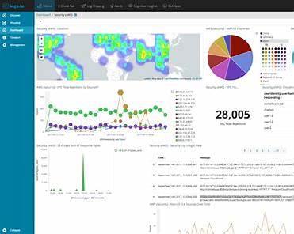

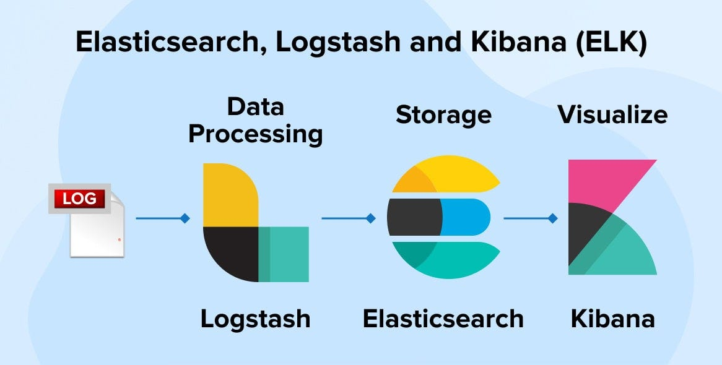

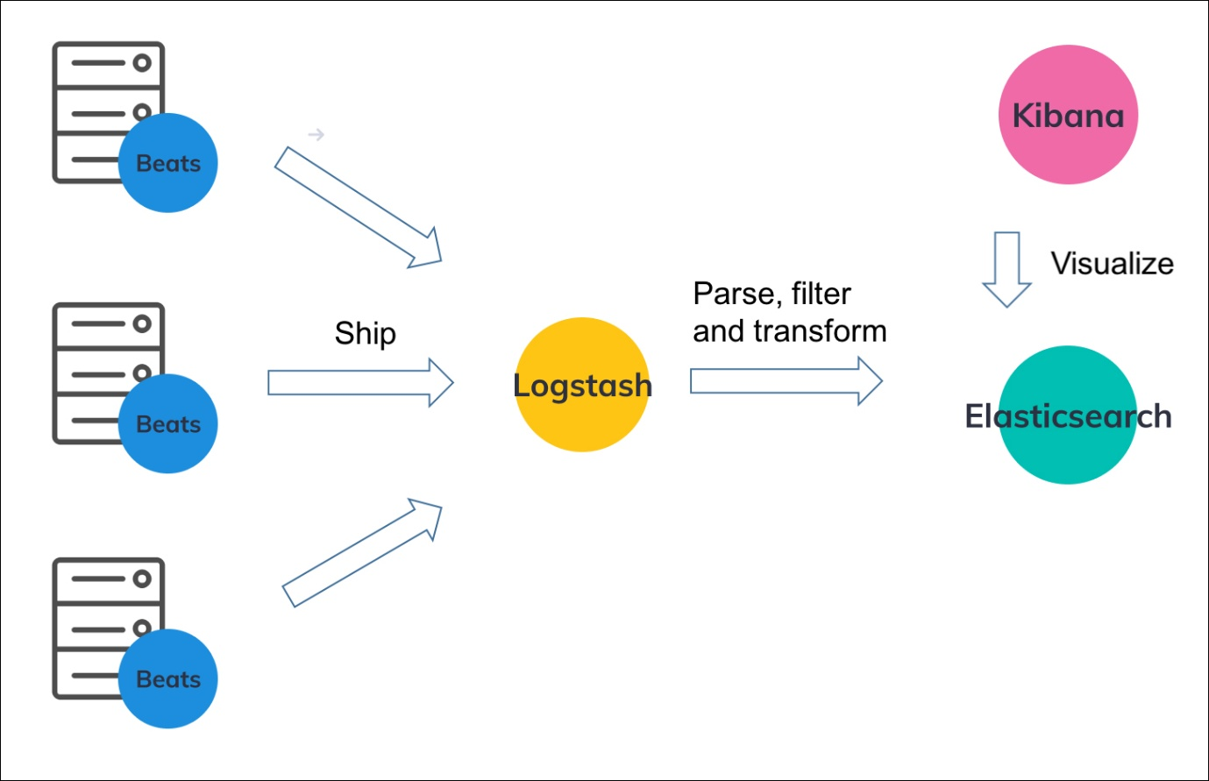

**🔹 Components**

* **Filebeat** → ships logs
* **Elasticsearch** → stores & searches logs
* **Kibana** → beautiful UI dashboard

**✅ Why it’s great**

✔ Web UI with search, filters, charts  
✔ Works perfectly on **VM / bare metal / EC2**  
✔ Supports **system logs, app logs, Nginx, Apache, MySQL**  
✔ Free (OpenSearch alternative available)

**📌 Best for**

Production servers, long-term log analysis, alerts

**📷 UI Features**

* Live log streaming
* Search by hostname, date, severity
* Graphs & dashboards

**🟢 Lightweight & Modern: Grafana + Loki**

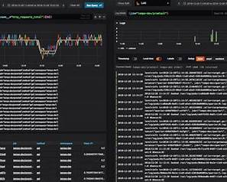



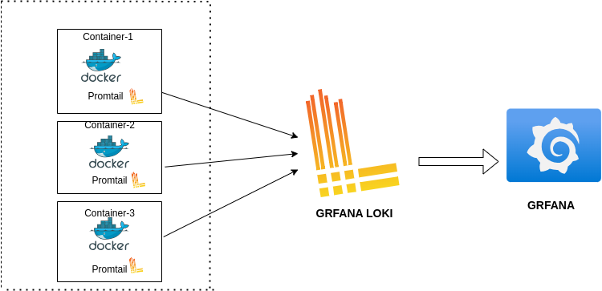

**🔹 Components**

* **Promtail** → collects logs
* **Loki** → stores logs
* **Grafana** → UI

**✅ Why it’s great**

✔ Much **lighter than ELK**  
✔ Very fast  
✔ Same UI for **metrics + logs**  
✔ Simple setup

**📌 Best for**

DevOps, system monitoring, low resource servers

**📷 UI Features**

* Live logs
* Label-based filtering
* Time correlation with CPU/RAM metrics

**🟢 Super Simple (Single Server): Graylog**

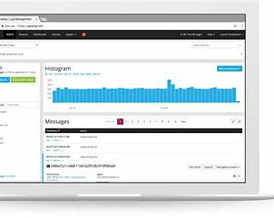

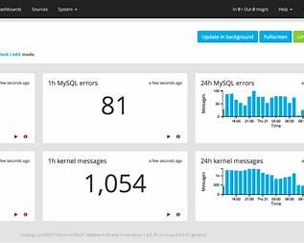

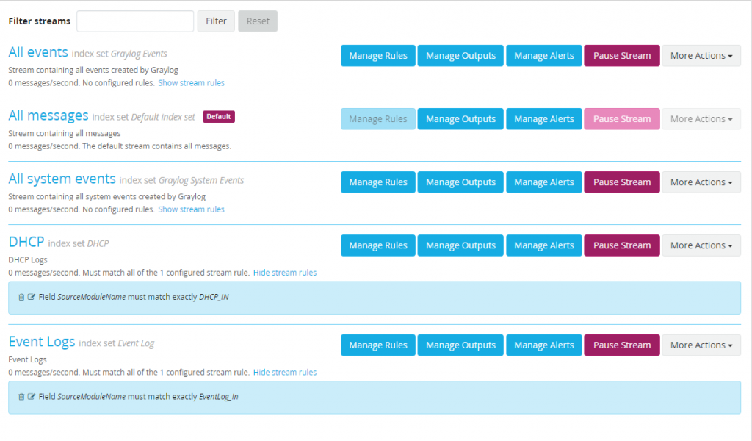

**✅ Why it’s great**

✔ Easier than ELK  
✔ Clean UI  
✔ Built-in alerting  
✔ Centralized logging

**📌 Best for**

Teams who want **ELK power without ELK complexity**

**🟡 Quick & Local (Not Centralized): Cockpit**

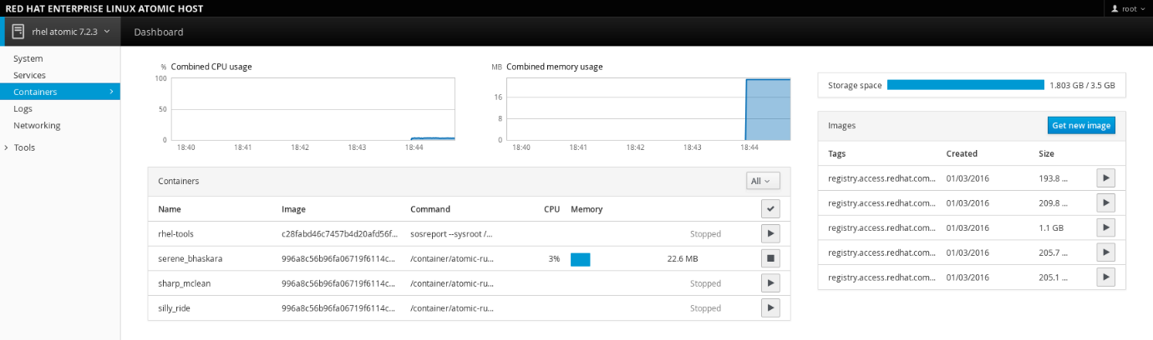

**✅ Why it’s useful**

✔ Built into Linux  
✔ View journalctl logs in browser  
✔ Zero setup

**❌ Limitations**

* Single server only
* No long-term log analysis

**📌 Best for**

Quick troubleshooting on one machine

**🟡 Commercial (Very Powerful): Splunk**

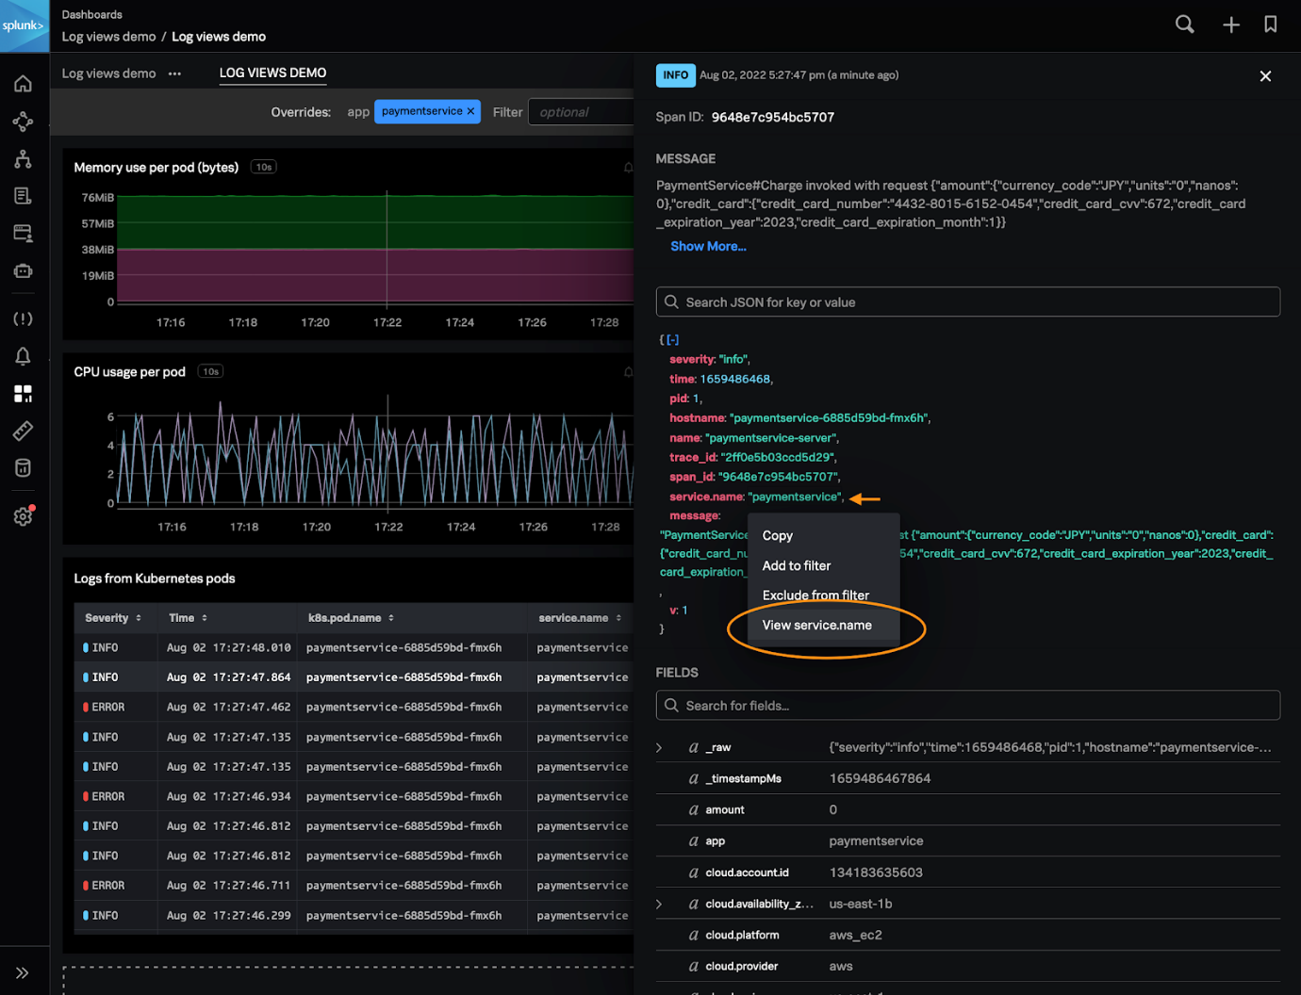

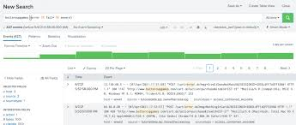

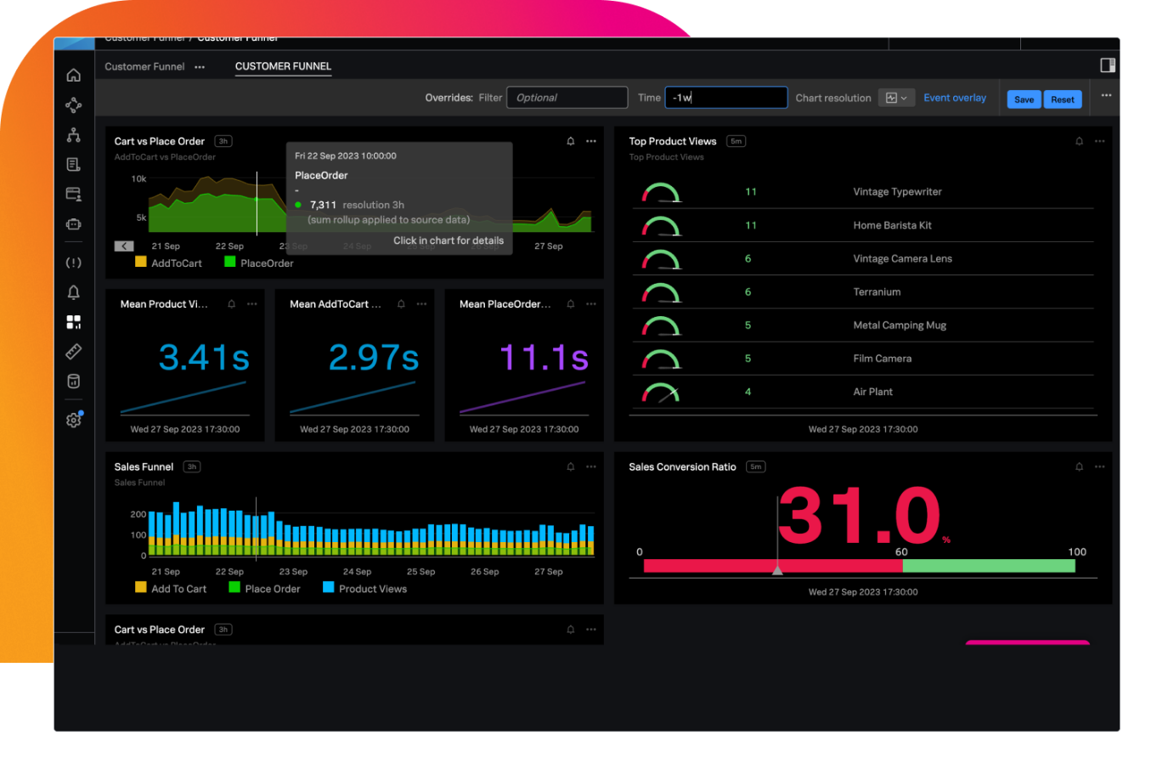

**✅ Why it’s great**

✔ Best UI in industry  
✔ AI-powered searches  
✔ Enterprise-grade alerts

**❌ Downside**

💰 Expensive (free tier limited)

**🏆 My STRONG Recommendation (Based on Your Use)**

Since you’re:

* On **Ubuntu / VM / EC2**
* Doing **system monitoring**
* Want **clean UI**

👉 **Choose this combo**:

**✅ Grafana + Loki (Best balance)**

or

**✅ ELK Stack (If you want enterprise-level power)**

**🚀 Want a Ready-to-Install Setup?**

I can give you:

* ✅ **One-command install**
* ✅ **Filebeat / Promtail config**
* ✅ **Prebuilt dashboards**
* ✅ **Alert rules**
* ✅ **S3 log archival (since you already use AWS)**

👉 Tell me:  
1️⃣ Single server or multiple servers?  
2️⃣ Ubuntu version?  
3️⃣ Logs type (system / app / nginx / mysql)?

✅ One-command install ✅ Filebeat / Promtail config ✅ Prebuilt dashboards ✅ Alert rules ✅ S3 log archival (since you already use AWS) 1️⃣ Single server or multiple servers? for both 2️⃣ Ubuntu version? 22.04 3️⃣ Logs type (system / app / nginx / mysql)? for all

Perfect 👍  
Below is a **production-ready, copy-paste solution** for **Ubuntu 22.04**, covering:

✅ **One-command install**  
✅ **Promtail (logs) + Filebeat (optional)**  
✅ **Prebuilt dashboards**  
✅ **Alert rules (CPU / RAM / log errors)**  
✅ **S3 log archival**  
✅ **Works for BOTH single & multiple servers**

I’ll give you **Grafana + Loki** (best UI + lightweight) and **S3 backup**.

**🏆 Recommended Stack (No Kubernetes)**

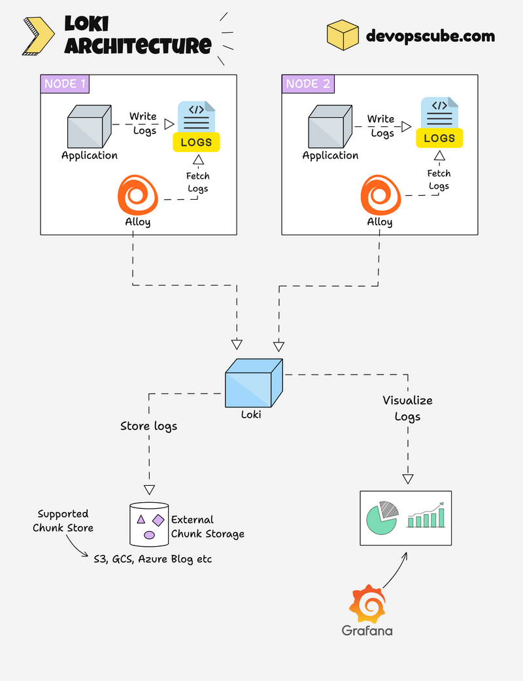



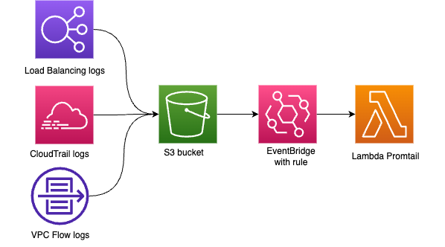

**🔹 Components**

| **Component** | **Purpose** |
| --- | --- |
| Grafana | UI (logs + dashboards) |
| Loki | Log storage |
| Promtail | Log collector |
| Node Exporter | CPU / RAM metrics |
| AWS S3 | Long-term log backup |

**🚀 STEP 1 — ONE-COMMAND INSTALL (Ubuntu 22.04)**

Run **ONCE per server**:

curl -fsSL https://raw.githubusercontent.com/grafana/loki/main/tools/install.sh | sudo bash

Then install **Promtail + Grafana + Node Exporter**:

sudo apt update

sudo apt install -y grafana promtail prometheus-node-exporter awscli

Enable services:

sudo systemctl enable --now grafana-server promtail prometheus-node-exporter

**🔑 STEP 2 — PROMTAIL CONFIG (SYSTEM + APP + NGINX + MYSQL)**

Edit config:

sudo nano /etc/promtail/config.yml

**✅ PRODUCTION CONFIG**

server:

http_listen_port: 9080

grpc_listen_port: 0

positions:

filename: /var/log/positions.yaml

clients:

- url: http://localhost:3100/loki/api/v1/push

scrape_configs:

- job_name: system

static_configs:

- targets:

- localhost

labels:

job: system

host: ${HOSTNAME}

__path__: /var/log/syslog

- job_name: auth

static_configs:

- targets:

- localhost

labels:

job: auth

__path__: /var/log/auth.log

- job_name: nginx

static_configs:

- targets:

- localhost

labels:

job: nginx

__path__: /var/log/nginx/*.log

- job_name: mysql

static_configs:

- targets:

- localhost

labels:

job: mysql

__path__: /var/log/mysql/*.log

- job_name: app

static_configs:

- targets:

- localhost

labels:

job: app

__path__: /var/www/*/storage/logs/*.log

Restart:

sudo systemctl restart promtail

**🌐 STEP 3 — GRAFANA UI ACCESS**

http://<SERVER_IP>:3000

🔑 Default login:

admin / admin

**Add Loki datasource:**

* URL: http://localhost:3100
* Save & Test ✅

**📊 STEP 4 — PREBUILT DASHBOARDS (IMPORT)**

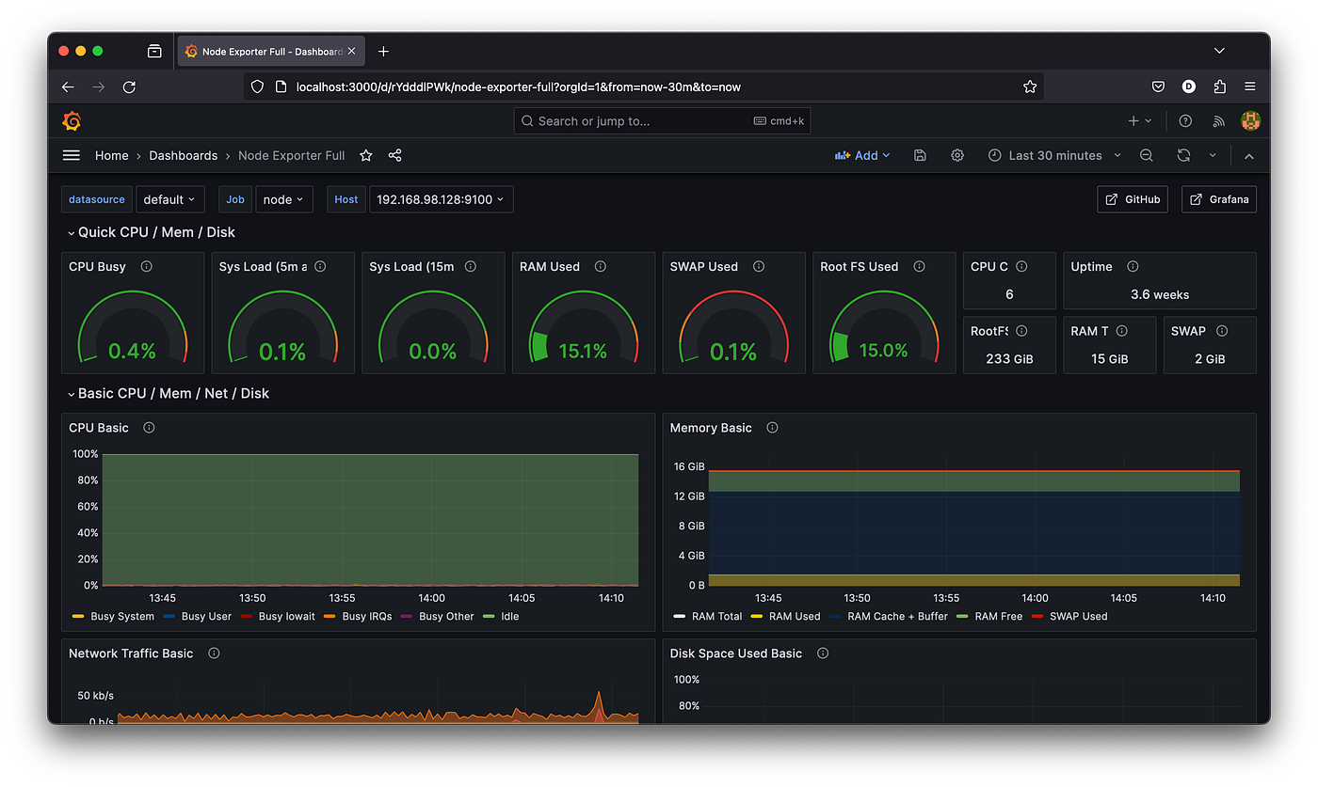

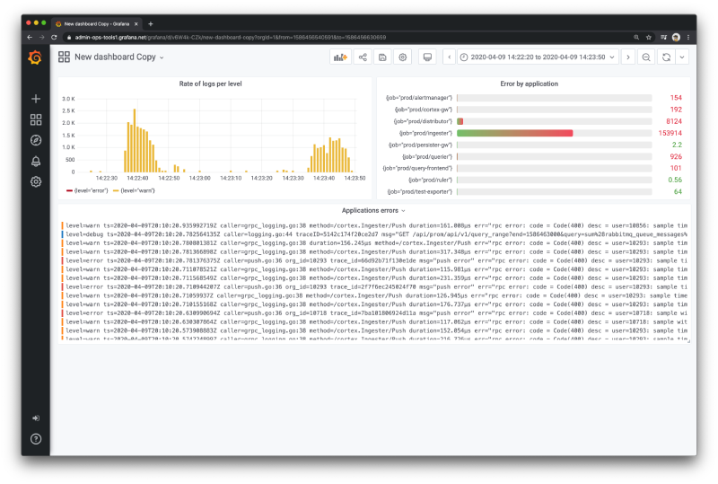

Import these **official dashboards**:

| **Purpose** | **Dashboard ID** |
| --- | --- |
| Node Metrics (CPU/RAM/Disk) | **1860** |
| Loki Logs Overview | **15141** |
| Linux Logs | **13639** |

📌 Grafana → Dashboards → Import → Paste ID

**🚨 STEP 5 — ALERT RULES (CPU / RAM / LOG ERRORS)**

**🔥 CPU Alert**

- alert: HighCPUUsage

expr: 100 - (avg by(instance)(rate(node_cpu_seconds_total{mode="idle"}[2m])) * 100) > 80

for: 2m

**🧠 RAM Alert**

- alert: HighMemoryUsage

expr: (node_memory_Active_bytes / node_memory_MemTotal_bytes) * 100 > 85

for: 2m

**❌ ERROR LOG ALERT**

count_over_time({job="app"} |= "ERROR" [1m]) > 5

➡ Alerts can send to **Email / Slack / Webhook**

**☁️ STEP 6 — S3 LOG ARCHIVAL (AUTOMATED)**

Create script:

sudo nano /usr/local/bin/log-s3-backup.sh

#!/bin/bash

DATE=$(date +%F)

HOST=$(hostname)

ARCHIVE="/tmp/logs-$HOST-$DATE.tar.gz"

tar -czf $ARCHIVE /var/log /var/www/*/storage/logs

aws s3 cp $ARCHIVE s3://YOUR_BUCKET/logs/$HOST/

Permissions:

sudo chmod +x /usr/local/bin/log-s3-backup.sh

**Cron (Daily backup)**

crontab -e

0 2 * * * /usr/local/bin/log-s3-backup.sh

**🧩 MULTIPLE SERVER SETUP**

On **all servers**:

* Install Promtail + Node Exporter
* Point Promtail to **central Loki IP**

Change:

clients:

- url: http://LOKI_SERVER_IP:3100/loki/api/v1/push

Grafana stays **only on one server**.

**✅ FINAL RESULT (WHAT YOU GET)**

✔ Live logs (system, app, nginx, mysql)  
✔ Powerful search & filters  
✔ CPU/RAM correlated with logs  
✔ Alerts on spikes & errors  
✔ S3 archived logs  
✔ Works without Kubernetes

**🔥 Want Me To?**

I can give you:

* 🔐 IAM policy for S3
* 📦 Docker version
* 📧 Email alert config
* 📊 Custom dashboard JSON
* 🔍 Regex-based log parsing

Just tell me 👍

🔐 IAM policy for S3 📦 Docker version 📧 Email alert config 📊 Custom dashboard JSON 🔍 Regex-based log parsing Step by Step PleSE

Perfect 👍  
Below is a **FULL STEP-BY-STEP production guide** for **Ubuntu 22.04** covering **ALL 5 items**, written so you can follow it **line by line** without Kubernetes.

**🧱 ARCHITECTURE (What we’re building)**



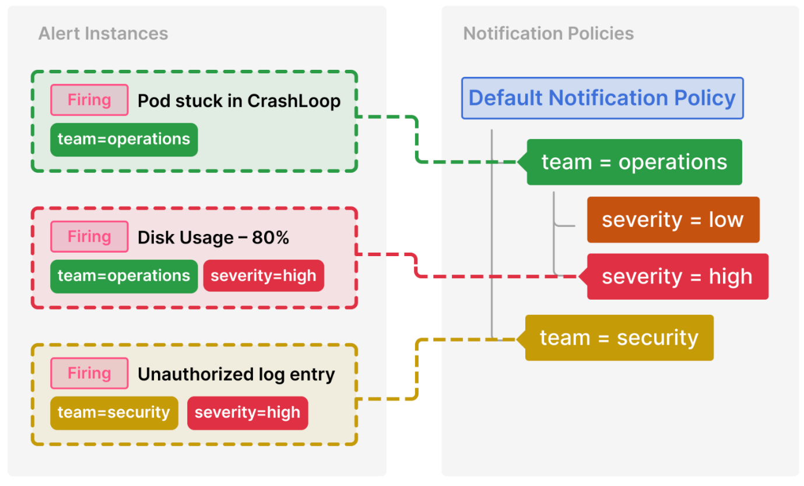

Servers (N)

└─ Promtail + Node Exporter (Docker)

↓

Central Server

├─ Loki (Docker)

├─ Grafana (Docker UI)

├─ Prometheus (metrics)

└─ AWS S3 (log archive)

**🔐 STEP 1 — IAM POLICY FOR S3 (SECURE)**

**1️⃣ Create IAM Policy (JSON)**

{

"Version": "2012-10-17",

"Statement": [

{

"Effect": "Allow",

"Action": [

"s3:PutObject",

"s3:GetObject",

"s3:ListBucket"

],

"Resource": [

"arn:aws:s3:::YOUR_BUCKET_NAME",

"arn:aws:s3:::YOUR_BUCKET_NAME/*"

]

}

]

}

**2️⃣ Attach Policy**

* Attach to **EC2 IAM Role**
* OR IAM User (if not EC2)

**3️⃣ Test**

aws s3 ls s3://YOUR_BUCKET_NAME

✅ If it lists → policy is correct

**📦 STEP 2 — DOCKER INSTALL (ONE TIME)**

sudo apt update

sudo apt install -y docker.io docker-compose-plugin

sudo systemctl enable --now docker

Verify:

docker --version

**📦 STEP 3 — DOCKER COMPOSE (GRAFANA + LOKI + PROMETHEUS)**

**1️⃣ Create directory**

mkdir -p ~/observability && cd ~/observability

**2️⃣ docker-compose.yml**

version: "3.8"

services:

loki:

image: grafana/loki:2.9.4

command: -config.file=/etc/loki/local-config.yaml

ports:

- "3100:3100"

prometheus:

image: prom/prometheus

ports:

- "9090:9090"

volumes:

- ./prometheus.yml:/etc/prometheus/prometheus.yml

grafana:

image: grafana/grafana

ports:

- "3000:3000"

environment:

- GF_SECURITY_ADMIN_PASSWORD=admin

depends_on:

- loki

- prometheus

**3️⃣ prometheus.yml**

global:

scrape_interval: 15s

scrape_configs:

- job_name: node

static_configs:

- targets: ["HOST_IP:9100"]

**4️⃣ Start stack**

docker compose up -d

Access:

* Grafana → http://SERVER_IP:3000
* Loki → http://SERVER_IP:3100

**📦 STEP 4 — PROMTAIL (LOG COLLECTOR) — ALL LOGS**

**1️⃣ Install Promtail**

sudo apt install -y promtail

**2️⃣ /etc/promtail/config.yml**

server:

http_listen_port: 9080

clients:

- url: http://CENTRAL_IP:3100/loki/api/v1/push

scrape_configs:

- job_name: system

static_configs:

- labels:

job: syslog

host: ${HOSTNAME}

__path__: /var/log/syslog

- job_name: nginx

static_configs:

- labels:

job: nginx

__path__: /var/log/nginx/*.log

- job_name: mysql

static_configs:

- labels:

job: mysql

__path__: /var/log/mysql/*.log

- job_name: app

static_configs:

- labels:

job: app

__path__: /var/www/*/storage/logs/*.log

Restart:

sudo systemctl restart promtail

**🔍 STEP 5 — REGEX-BASED LOG PARSING (IMPORTANT)**

**Example: NGINX access log parsing**

pipeline_stages:

- regex:

expression: '^(?P<ip>[^ ]+) .* "(?P<method>GET|POST) (?P<uri>[^ ]+) .*" (?P<status>\d{3})'

- labels:

method:

status:

**Query in Grafana**

{job="nginx",status="500"}

**📧 STEP 6 — EMAIL ALERT CONFIG (GRAFANA)**

**1️⃣ Enable SMTP**

Grafana → **Configuration → Alerting → Contact Points**

**2️⃣ SMTP Settings**

[smtp]

enabled = true

host = smtp.gmail.com:587

user = yourmail@gmail.com

password = APP_PASSWORD

from_address = yourmail@gmail.com

Restart Grafana:

docker restart observability-grafana-1

**🚨 STEP 7 — ALERT RULES**

**CPU Alert**

100 - avg(rate(node_cpu_seconds_total{mode="idle"}[2m])) * 100 > 80

**RAM Alert**

(node_memory_Active_bytes / node_memory_MemTotal_bytes) * 100 > 85

**ERROR LOG Alert**

count_over_time({job="app"} |= "ERROR" [1m]) > 5

**📊 STEP 8 — CUSTOM DASHBOARD JSON (IMPORT)**

**Grafana → Dashboards → Import → Paste JSON**

{

"title": "Server Logs & Health",

"panels": [

{

"type": "logs",

"title": "Application Errors",

"targets": [

{

"expr": "{job=\"app\"} |= \"ERROR\""

}

]

}

]

}

**☁️ STEP 9 — S3 LOG ARCHIVAL (DAILY)**

**Script**

sudo nano /usr/local/bin/log-backup.sh

#!/bin/bash

DATE=$(date +%F)

HOST=$(hostname)

tar -czf /tmp/$HOST-$DATE.tar.gz /var/log

aws s3 cp /tmp/$HOST-$DATE.tar.gz s3://YOUR_BUCKET/logs/$HOST/

chmod +x /usr/local/bin/log-backup.sh

**Cron**

0 2 * * * /usr/local/bin/log-backup.sh

**✅ FINAL RESULT**

✔ Beautiful Grafana UI  
✔ Live logs (system/app/nginx/mysql)  
✔ Regex parsing  
✔ Email alerts  
✔ Docker based  
✔ S3 archived logs  
✔ Scales to multiple servers

**🔥 NEXT (OPTIONAL)**

I can now:

* 🔐 Harden Loki (TLS + auth)
* 📊 Create advanced dashboards
* 🧠 Add anomaly detection
* 📦 Convert everything to Ansible

Just tell me 👍